A PROJECT REPORT
on
HARVESTHUB
Farm Management & Crop Planning System
Crop Rotation Planning • Field Operations • Cost & Yield Tracking • Equipment Maintenance Scheduling
Submitted in partial fulfilment of the requirements for the award of the degree of
COMPUTER SCIENCE
Specialisation: Full Stack Development
Submitted by
Akshay Choudhary
2400320100135
Under the guidance of
[Guide Name], [Designation]
Project Code: P_008
Department of Computer Science & Engineering
ABES Engineering College
Academic Year 2026-27

CERTIFICATE

This is to certify that the project report entitled “HarvestHub: Farm Management & Crop Planning System” is a bona fide work carried out by Akshay Choudhary 2400320100135 in partial fulfilment of the requirements for the award of the degree of B-Tech in the Department of CSE, ABES Engineering College, during the academic year 2026-27.
The project has been carried out under my supervision and guidance. To the best of my knowledge, the work embodied in this report is original, has not been submitted earlier to this or any other university or institute for the award of any degree or diploma, and is worthy of consideration for the award of the degree.

[Guide Name] [Head of Department]
Project Guide Department of [Department Name]

Date: ____________ External Examiner: ____________
Place: ____________

ACKNOWLEDGEMENT

I would like to express my sincere gratitude to everyone who supported me during the design and development of the project “HarvestHub: Farm Management & Crop Planning System”.
First and foremost, I am deeply thankful to my project guide, [Guide Name], [Designation], Department of [Department Name], for the continuous guidance, constructive criticism and encouragement provided at every stage of this work. Their insights into structuring the system and their patience in reviewing each milestone were invaluable.
I extend my heartfelt thanks to [Head of Department Name], Head of the Department, and to [Principal / Director Name], [Name of Institution], for providing the laboratory facilities, resources and an environment conducive to learning and research.
I am grateful to the farmers, agricultural extension officers and agronomy students who shared their practical knowledge of crop cycles, rotation practices, field operations and machinery upkeep. Their real-world inputs shaped the requirements of this system and kept it grounded in the day-to-day needs of farm operations.
I also thank the faculty members and the technical staff of the department for their timely help, and my friends for their honest feedback during testing. Finally, I owe my deepest appreciation to my family for their unwavering support, motivation and faith in me throughout this journey.

Akshay Choudhary
2400320100135

ABSTRACT

Farming decisions are driven by long cycles of planning, execution and review, yet most small and medium farms still manage them through paper diaries, memory and scattered spreadsheets. This leads to repeated cultivation of the same crop family on the same land, missed field operations, untracked expenses, unreliable yield figures and machinery that breaks down at critical times such as sowing and harvest.
HarvestHub is a full-stack web application designed to bring farm planning and record keeping into a single system. It provides four core capabilities: (1) crop rotation planning that validates plans against agronomic rules such as crop-family gaps and legume-after-cereal recommendations; (2) field operations management covering ploughing, sowing, irrigation, fertilisation, spraying, weeding and harvesting with scheduling and completion logs; (3) cost and yield tracking that computes cost per acre, yield per acre, revenue, gross margin and benefit–cost ratio for every crop cycle; and (4) equipment maintenance scheduling that generates service alerts based on calendar intervals and machine-hour usage.
The system is implemented using Java and the Spring Boot framework with a relational database, following the Model–View–Template pattern, role-based access control and a responsive Bootstrap interface with Chart.js dashboards. The report presents the problem background, requirement analysis, system design, database design, module description, implementation, testing and results. Testing shows that the system correctly enforces rotation rules, produces accurate cost and yield analytics, and raises maintenance alerts on time, making HarvestHub a practical decision-support tool for farm owners and managers.
Keywords: Farm Management, Crop Rotation, Field Operations, Cost–Yield Analysis, Equipment Maintenance, Full Stack Development, Precision Agriculture.

TABLE OF CONTENTS

CERTIFICATE i
ACKNOWLEDGEMENT ii
ABSTRACT iii
TABLE OF CONTENTS iv
Chapter 1: Introduction 1
Chapter 2: System Study and Feasibility 3
Chapter 3: Requirement Analysis 4
Chapter 4: System Design 6
Chapter 5: Module Description 8
Chapter 6: Testing 10
Chapter 7: Results and Screen Descriptions 11
Chapter 8: Conclusion and Future Scope 12
References 13

LIST OF FIGURES AND TABLES
No. | Title
Figure 4.1 | Layered system architecture of HarvestHub
Figure 4.2 | Entity–Relationship diagram
Table 3.1 | Actors and their privileges
Table 3.2 | Hardware and software requirements
Table 4.1 | Data dictionary – core tables
Table 5.1 | Crop-family rotation rules
Table 7.1 | Summary of test cases

Chapter 1: Introduction

1.1 Background
Agriculture is the backbone of the Indian economy and supports the livelihood of a large share of the population. Modern farming, however, is no longer just about sowing and harvesting. A farm manager must decide what to grow in which field, when to sow, which operations to perform and in what order, how much to spend, how much to expect, and when machines must be serviced. These decisions repeat every season and depend on what happened in earlier seasons.
Crop rotation, the practice of growing different crops in a planned sequence on the same land, is central to sustainable farming. It breaks pest and disease cycles, balances soil nutrients, improves soil structure and reduces dependence on chemical inputs. Yet planning rotations across several fields and several years is difficult to do manually.

1.2 Problem Statement
Farms commonly face the following problems:
- Rotation plans are kept in memory or on paper, so the same crop family is often planted in the same field in consecutive seasons.
- Field operations such as irrigation, fertiliser application and spraying are missed or delayed because there is no central schedule.
- Expenses (seed, labour, fuel, fertiliser, pesticide, rent) are not linked to specific crop cycles, making profit calculation unreliable.
- Yield data is not recorded consistently, so performance cannot be compared across fields, crops and seasons.
- Tractors, pumps and harvesters are serviced only after breakdowns, causing costly downtime during critical periods.

1.3 Objectives
- To design a web-based system that plans multi-year crop rotations and validates them against agronomic rules.
- To schedule, assign and record field operations for every crop cycle.
- To capture costs and yields per crop cycle and compute profitability indicators.
- To schedule preventive maintenance of farm equipment using time and usage-hour intervals.
- To provide role-based access, dashboards and downloadable reports for informed decision making.

1.4 Scope of the Project
HarvestHub is intended for small and medium farms, farmer producer groups and agricultural cooperatives that manage multiple fields and a shared pool of equipment. The system covers planning, operations, finance, yield and machinery management. It does not include IoT sensor integration, satellite imagery, or online sale of produce, which are noted as future enhancements.

1.5 Technology Choice
The project is implemented using Java and Spring Boot framework, chosen for its “batteries-included” design (ORM, authentication, admin, form handling), rapid development and strong security defaults. The data layer uses a relational database; the design is portable so that Oracle can be used in place of the default engine by changing the mysql database configuration. The front end uses Bootstrap 5 and Chart.js.

1.6 Organisation of the Report
Chapter 2 reviews the existing systems and proposes the new one. Chapter 3 covers requirement analysis. Chapter 4 presents the system and database design. Chapter 5 describes each module. Chapter 6 discusses implementation. Chapter 7 covers testing. Chapter 8 presents results and screens, and Chapter 9 concludes the report with future scope.

Chapter 2: System Study and Feasibility

2.1 Existing System
On most farms the current process relies on handwritten diaries, verbal instructions to workers, and occasional spreadsheets. Some commercial farm-management products exist, but they are often costly, oriented toward large commercial estates, or lack support for local crops, seasons (Kharif, Rabi, Zaid) and units such as acres, bigha and quintal.

2.2 Limitations of the Existing System
- No automated validation of crop rotation, leading to soil fatigue and pest build-up.
- Information is fragmented and difficult to search or summarise.
- No reminders for pending operations or upcoming equipment servicing.
- Cost and yield are not tied to a common crop-cycle record, so profit per acre is unknown.
- Data is easily lost, and there is no audit trail or multi-user access.

2.3 Proposed System
HarvestHub centralises all farm data. Each field has a rotation plan made up of crop cycles; each crop cycle has scheduled operations, expenses and yield records; and each machine has a maintenance schedule. The system checks rotation rules automatically, sends due-date alerts and computes analytics on demand.

2.4 Feasibility Study

2.4.1 Technical Feasibility
All required technologies (Java, Oracle, a relational database, Bootstrap, Chart.js) are open source, well documented and run on ordinary hardware. The project is technically feasible.

2.4.2 Economic Feasibility
Because open-source tools are used and hosting needs are modest, the development and running costs are low. The expected savings from better rotation, reduced downtime and accurate costing outweigh the investment.

2.4.3 Operational Feasibility
The interface uses simple forms, calendars and colour-coded status labels so that users with limited computer experience can adopt it with minimal training. The application is responsive and can be used on a smartphone in the field.

2.5 Agricultural Domain Concepts
- Crop cycle – Crop cycle: the period from land preparation and sowing to harvest of a single crop in a field.
- Seasons – Kharif (monsoon, June–October), Rabi (winter, November–April) and Zaid (summer, March–June).
- Crop family – Groups of botanically related crops (cereals, legumes, oilseeds, solanaceous vegetables, etc.) that share pests and nutrient needs.
- Field operations – Tasks such as tillage, sowing, irrigation, fertilising, spraying, weeding and harvesting.
- Preventive maintenance – Preventive servicing performed at fixed time or machine-hour intervals to avoid breakdown.

Chapter 3: Requirement Analysis

3.1 Actors
Actor | Description | Key privileges
Farm Owner | Owns the farm; needs the overall picture | Full access; approves plans; views financial reports
Farm Manager | Plans and supervises operations | Create rotation plans, schedule operations, record costs and yields
Field Worker | Performs field tasks | View assigned tasks; mark operations complete; log labour hours
Mechanic | Maintains machinery | Manage equipment, service logs and maintenance tasks
Administrator | Technical administrator | Manage users, roles, master data (crops, soil types)
Table 3.1: Actors and their privileges

3.2 Functional Requirements

3.2.1 Authentication and User Management
- Secure registration, login, logout and password reset.
- Role-based access control with permissions per module.

3.2.2 Farm, Field and Master Data
- Create and maintain farms, fields (area, soil type, irrigation source) and crop master data (family, duration, season, expected yield).

3.2.3 Crop Rotation Planning
- Create multi-year rotation plans per field and assign crops to seasons.
- Validate each proposed crop against the field’s history and rotation rules; display warnings and suggestions.
- View a season-wise rotation calendar for all fields.

3.2.4 Field Operations
- Schedule operations against a crop cycle with date, assignee, equipment and inputs.
- Record completion, actual date, labour hours and remarks; auto-generate a standard operation checklist from a crop template.

3.2.5 Cost and Yield Tracking
- Record expenses by category linked to a crop cycle and record harvest quantity and selling price.
- Compute cost per acre, yield per acre, revenue, gross margin and benefit–cost ratio; compare crops, fields and seasons.

3.2.6 Equipment Maintenance
- Maintain equipment register (type, purchase date, hours used, status).
- Define maintenance schedules by days and/or machine hours; generate alerts when due; record service history and cost.

3.2.7 Dashboard and Reports
- Dashboard with upcoming operations, overdue tasks, maintenance alerts, expense and yield charts.
- Export of reports to PDF and CSV.

3.3 Non-Functional Requirements
- Performance – Response time under three seconds for common pages with typical farm data volumes.
- Security – Password hashing, CSRF protection, input validation and session security.
- Usability – Simple, mobile-friendly interface with clear status colours.
- Reliability – Regular database backups; transactional integrity for cost and yield entries.
- Portability – Portable across operating systems and database engines.

3.4 Hardware and Software Requirements
Category | Specification
Processor / RAM | Intel Core i3 or higher / 4 GB RAM (8 GB recommended)
Storage | Minimum 10 GB free disk space
Operating system | Windows 10/11, Linux or macOS
Language and framework | Java, Spring Boot
Database | Relational DB (SQLite for development; PostgreSQL / Oracle for production)
Front end | HTML5, CSS3, JavaScript, Bootstrap 5, Chart.js
Tools | VS Code / Intillij, Git, Postman, Browser (Chrome / Firefox / Edge)
Table 3.2: Hardware and software requirements

Chapter 4: System Design

4.1 Architecture
HarvestHub follows a layered architecture built on Django’s Model–View–Template (MVT) pattern. The user layer interacts through a browser; the presentation layer renders templates and charts; the application layer contains separate Django apps for each functional area; and the data layer persists information through the Django ORM in a relational database.
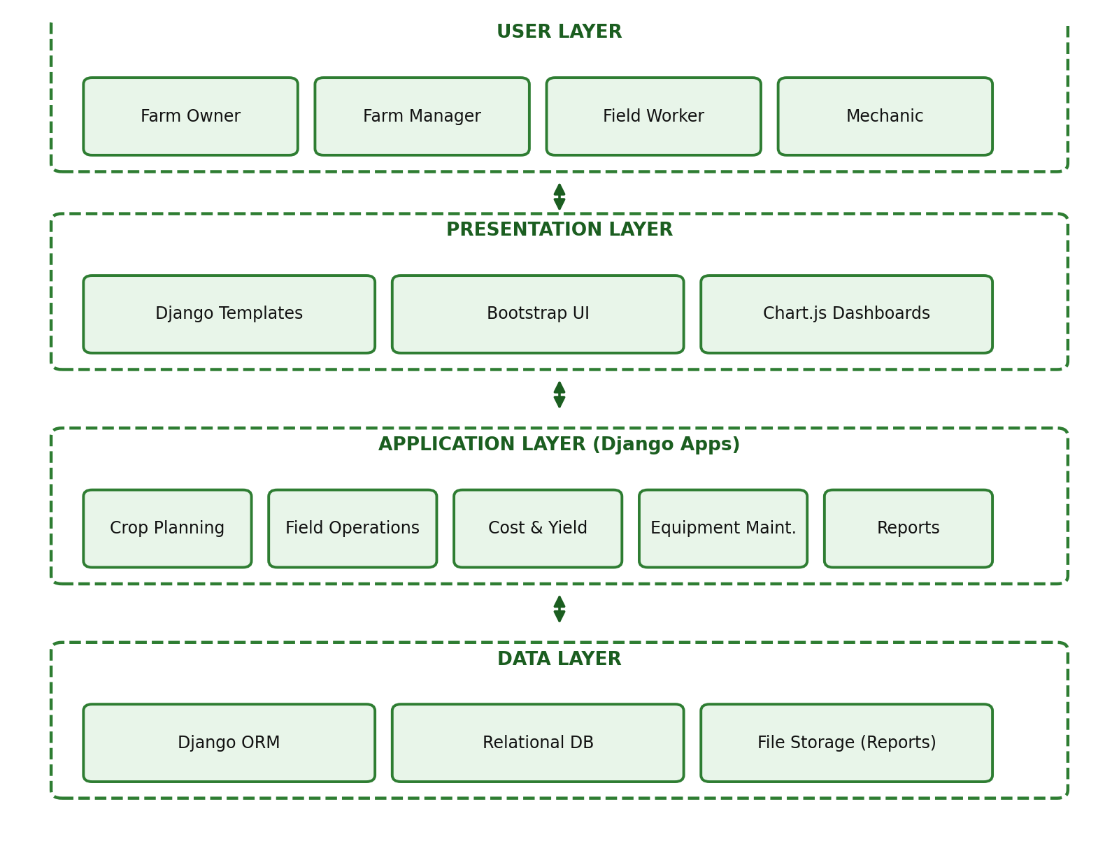
Figure 4.1: Layered system architecture of HarvestHub

4.2 Data Flow Diagrams

Level 0 (Context Diagram)
The single process “HarvestHub System” exchanges data with three external entities: the Farm Owner/Manager (plans, cost and yield data in; reports and alerts out), the Field Worker (task completion data in; task lists out) and the Mechanic (service records in; maintenance alerts out).

Level 1
- Manage Master Data – stores farms, fields and crop details in the master data store.
- Plan Rotation – reads field history and rotation rules, writes rotation plans and crop cycles.
- Manage Operations – reads crop cycles, writes operation schedules and completion logs.
- Track Cost & Yield – reads crop cycles, writes expenses and yield records, produces analytics.
- Schedule Maintenance – reads equipment and usage hours, writes maintenance tasks and alerts.
- Generate Reports – reads all stores and produces dashboards, PDFs and CSV files.

4.3 Entity–Relationship Diagram
The ER model captures how a farm contains fields, how each field carries rotation plans and crop cycles, and how every crop cycle collects operations, expenses and yield records. Equipment is maintained independently through maintenance tasks and is linked to operations through usage hours.
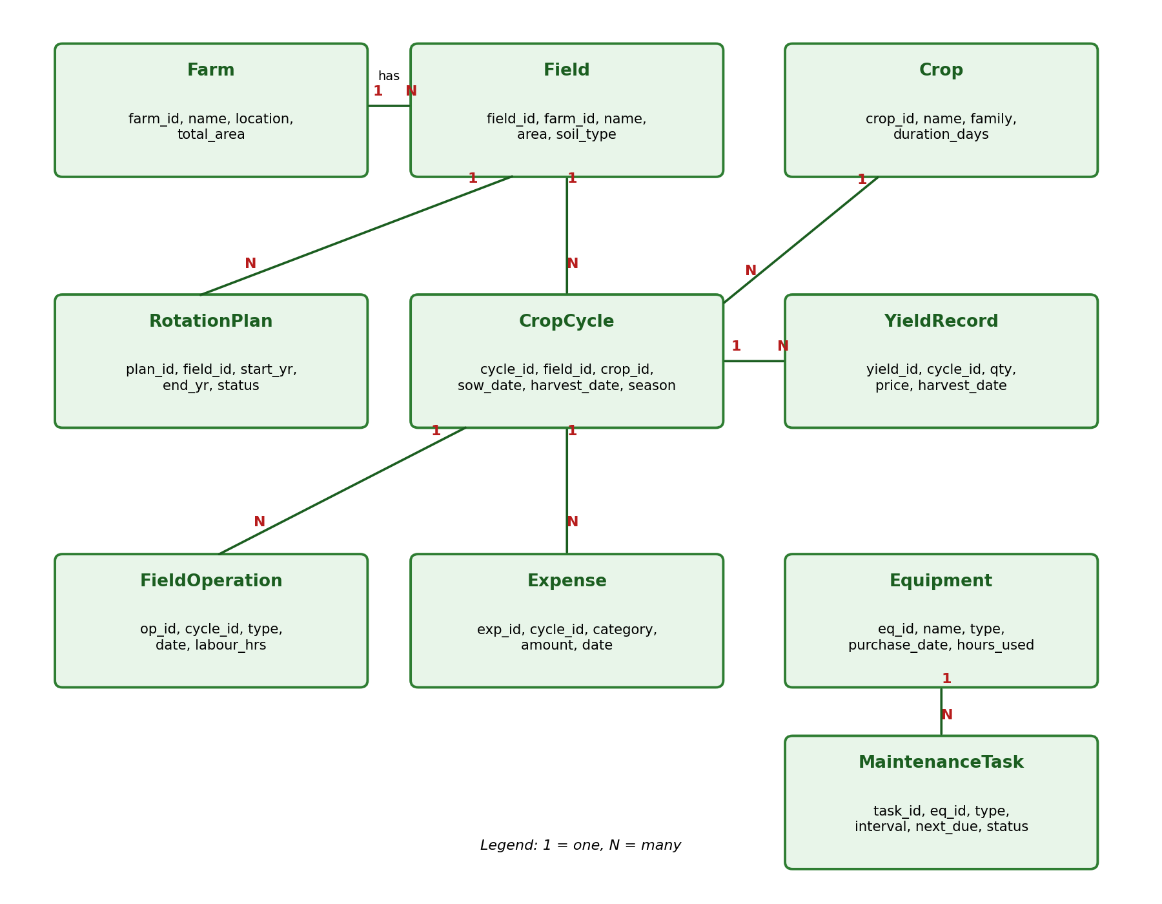
Figure 4.2: Entity–Relationship diagram

4.4 Database Design
The core tables are normalised to Third Normal Form. Table 4.1 lists the main attributes.
Table | Key attributes | Notes
Farm | farm_id (PK), name, location, total_area, owner_id (FK) | One owner, many fields
Field | field_id (PK), farm_id (FK), name, area_acres, soil_type, irrigation_source | Unit of planning
Crop | crop_id (PK), name, family, season, duration_days, exp_yield_per_acre | Master data
RotationPlan | plan_id (PK), field_id (FK), start_year, end_year, status | Draft / Approved / Active
CropCycle | cycle_id (PK), field_id (FK), crop_id (FK), plan_id (FK), season, year, sow_date, harvest_date, status | Core transaction record
FieldOperation | op_id (PK), cycle_id (FK), op_type, scheduled_date, actual_date, assigned_to (FK), equipment_id (FK), labour_hours, status | Planned vs. actual
Expense | exp_id (PK), cycle_id (FK), category, amount, date, description | Categories: seed, labour, fuel, fertiliser, etc.
YieldRecord | yield_id (PK), cycle_id (FK), quantity_qtl, price_per_qtl, harvest_date | Revenue = qty × price
Equipment | eq_id (PK), name, type, purchase_date, hours_used, status | Tractor, pump, harvester …
MaintenanceTask | task_id (PK), eq_id (FK), task_type, interval_days, interval_hours, last_done_date, last_done_hours, next_due_date, status, cost | Preventive schedule
Table 4.1: Data dictionary – core tables

4.5 Use Case Summary
- Manager creates rotation plan → system validates → Owner approves.
- Manager schedules operations → Worker views and completes → system updates the crop-cycle timeline.
- Manager logs expenses and yield → system computes profitability.
- Mechanic defines maintenance interval → system raises alerts as the due date or hours approach → Mechanic logs service.

Chapter 5: Module Description

5.1 Crop Rotation Planning Module
This module allows a manager to build a multi-year plan for each field. When a crop is assigned to a season, the rules engine reviews the previous cycles of that field and reports whether the choice is acceptable.
Rule | Description | Result
Same-family gap | The same crop family must not be grown again before a minimum gap (e.g., 1–2 seasons) | Error / Warning
Legume after cereal | A legume (gram, pea, lentil, soybean) after a cereal (wheat, rice, maize) restores nitrogen | Recommendation
Heavy feeder spacing | Avoid two heavy feeders (e.g., maize, cotton) in succession | Warning
Season compatibility | Crop must be suited to the selected season (Kharif / Rabi / Zaid) | Error
Fallow / green manure | Suggest fallow or green manure after three intensive crops | Suggestion
Table 5.1: Crop-family rotation rules
Outputs include a season-wise rotation calendar (fields as rows, seasons as columns) with colour-coded validity and a “suggest next crop” feature listing crops that satisfy all rules.

5.2 Field Operations Module
When a crop cycle is created, the system generates a checklist from the crop template, for example: land preparation → sowing → basal fertiliser → irrigation → weeding → pest spraying → harvesting. Each operation has an assignee, an optional piece of equipment, the inputs used and a due date.
- Calendar and list views of upcoming and overdue operations.
- Workers mark tasks complete from mobile; actual date and labour hours are recorded.
- Equipment usage hours are automatically added to the equipment’s meter when an operation completes, linking this module to maintenance scheduling.
- Operation costs (labour, fuel) are pushed to the expense ledger.

5.3 Equipment Maintenance Scheduling Module
Each equipment item has one or more maintenance tasks (engine-oil change, filter replacement, greasing, blade sharpening, tyre check, pump-seal inspection). A task can be time-based (every N days), usage-based (every N machine hours) or both.
- The next due date is calculated as the earlier of the calendar due date and the projected date for the hour-based due point.
- Alerts are shown 7 days or 10 machine-hours ahead, and marked overdue when passed.
- Each service record stores date, hours reading, parts used, service provider and cost; the cost is also reported in the farm’s overall expenses.
- Equipment history helps decide when a machine should be replaced.

5.4 Dashboard and Reporting Module
- Summary cards: active crop cycles, operations due this week, overdue maintenance, season profit.
- Charts: expense by category, yield by field, monthly cost trend, profit per crop.
- Reports: rotation plan, operations log, cost–yield statement and maintenance history, exportable to PDF and CSV.

5.5 User and Access Management Module
Built on an authentication system with groups for Owner, Manager, Worker and Mechanic. Views are protected using permission decorators, and workers only see tasks assigned to them.

Chapter 6: Testing

6.1 Testing Strategy
- Unit testing – Each function (rule validation, cost computation, due-date calculation) was tested with the test framework.
- Integration testing – Interaction between apps (e.g., an operation completion updating equipment hours and expense records) was verified.
- System testing – Complete user scenarios were executed from the user interface.
- User acceptance testing – Sample users (manager, worker, mechanic) exercised the system with realistic farm data.

6.2 Test Cases
ID | Module | Test scenario | Expected result | Status
TC01 | Accounts | Login with valid credentials | User reaches role-specific dashboard | Pass
TC02 | Accounts | Worker opens the finance page | Access denied (403) | Pass
TC03 | Planning | Assign wheat after wheat in the same field | Error: same-family gap violated | Pass
TC04 | Planning | Assign gram after wheat | Info: legume-after-cereal recommendation | Pass
TC05 | Planning | Assign a Kharif crop in Rabi season | Error: season mismatch | Pass
TC06 | Operations | Create crop cycle for paddy | Default operation checklist generated | Pass
TC07 | Operations | Complete a tractor ploughing task with 5 hours | Tractor meter increases by 5 h | Pass
TC08 | Finance | Add expense of ₹12,000 to a 4-acre cycle | Cost per acre = ₹3,000 | Pass
TC09 | Finance | Add yield 80 qtl @ ₹2,200 with cost ₹120,000 | Revenue ₹176,000; B:C ≈ 1.47 | Pass
TC10 | Finance | Enter negative amount | Validation error shown | Pass
TC11 | Equipment | Task every 250 h, meter at 245 h | Status DUE_SOON | Pass
TC12 | Equipment | Calendar interval passed | Status OVERDUE and alert on dashboard | Pass
TC13 | Reports | Export cost–yield report | PDF/CSV downloaded with correct totals | Pass
Table 7.1: Summary of test cases

6.3 Observations
All test cases passed after fixing three defects found in early testing: an off-by-one error in the rotation-history window, incorrect rounding in cost-per-acre display and a missing permission check on the maintenance edit page. The system performed responsively with datasets of several hundred crop cycles.

Chapter 7: Results and Screen Descriptions

7.1 Dashboard
The dashboard opens with summary cards for active crop cycles, operations due this week, overdue maintenance and current-season profit. Below them, charts show expense distribution by category and yield by field, with lists of upcoming operations and maintenance alerts.

7.2 Rotation Planner
The rotation planner presents a grid of fields against seasons. Selecting a cell opens a form to choose the crop; validation messages appear instantly. Green cells indicate approved rotations, amber cells warnings and red cells rule violations.

7.3 Field Operations
Operations are shown as a sortable list and a monthly calendar. Overdue tasks are highlighted in red. Workers see a simplified mobile view with large “Mark complete” buttons.

7.4 Cost and Yield Analytics
For each crop cycle the analytics screen shows cost by category, yield versus expected yield, revenue, gross margin and B:C ratio. A comparison view ranks crops and fields to support planning for the next season.

7.5 Equipment and Maintenance
The equipment page lists every machine with its hour meter, next service date and a coloured status chip. Selecting a machine shows its full service history and the cost of maintenance to date.

7.6 Outcomes
- Rotation conflicts are detected before sowing rather than after yield loss.
- Every operation and expense is traceable to a crop cycle.
- Farm profitability is visible per acre, per crop and per season.
- Preventive maintenance reduces unplanned breakdowns during sowing and harvest windows.

Chapter 8: Conclusion and Future Scope

8.1 Conclusion
HarvestHub successfully integrates crop rotation planning, field operations, cost and yield tracking and equipment maintenance scheduling into a single full-stack application. By encoding agronomic rules in software, linking every activity and expense to a crop cycle, and issuing timely maintenance alerts, the system replaces scattered manual records with reliable, actionable information. The project also demonstrated the practical use of Django’s MVT architecture, ORM, role-based security and modular design in a real-world domain.

8.2 Limitations
- Rotation rules are rule-based and generic; they are not yet tuned to region-specific soil or climate data.
- Data entry is manual; there is no automatic capture from sensors or machine telemetry.
- The application requires internet connectivity, which can be limited in rural areas.

8.3 Future Scope
- Weather API integration for irrigation and spraying advice.
- IoT soil-moisture sensors and GPS-based machine-hour tracking.
- Machine-learning models for yield prediction and crop recommendation.
- Offline-capable mobile app (PWA) with regional-language support and voice input.
- Market-price integration and inventory management of seeds, fertilisers and produce.
- Integration with government schemes, soil-health cards and crop-insurance workflows.

References
- Bootstrap Team, “Bootstrap 5 Documentation,” https://getbootstrap.com/docs/5.3/.
- Chart.js Contributors, “Chart.js Documentation,” https://www.chartjs.org/docs/.
- Food and Agriculture Organization of the United Nations, “Crop rotation and sustainable soil management,” FAO publications.
- Indian Council of Agricultural Research (ICAR), “Handbook of Agriculture,” ICAR, New Delhi.
- Ministry of Agriculture & Farmers Welfare, Government of India, “Agricultural Statistics at a Glance.”
- R. Elmasri and S. Navathe, “Fundamentals of Database Systems,” Pearson.
- I. Sommerville, “Software Engineering,” Pearson.
- A. Melé, “Django 5 by Example,” Packt Publishing.

